Aim: To get an insight of the word of pollinators.

Steps → Find a LOGO of the project with the title of ***BEE the Universe!***

Introduce the school, teachers and students, add parental consents.

LINK for voting→ volunteer teacher Deadline 30 March

Students group 5-15 students between age 10-12

Introduction– who are the pollinators. The process of pollination

Main Task → ***A Journey around the world*** eBook Each team chooses a continent and a pollinator can be chosen for being the guide → The students write a story of the travel and they can draw with any technique or insert a video with the source. 5 pages/team

eBOOK:<https://www.canva.com/design/DAF7oXoMGSM/UrExtUHRCHSumL3UJEVDSg/edit>

Video: <https://invideo.io/make/ai-video-generator/>

Mixed team:

| Group 1 Members | Tasks | Mentor |
| --- | --- | --- |
| LEVENTE, ROBI, OLIVÉR (HU)  Vîrlan Alexandra, Caloianu Ana ( RO)  Deniz (yfrmo), Aydöne(yfrmo),  Eliza Buttigieg, Clara Spina, Faye Muscat, Ylenia Pulis (MALTA)  Hasan (Çalkaya) | Continent:[**Asia**](https://www.worldometers.info/geography/7-continents/asia/)  Guide- drawing or any technique MALTA  Script (YFRMO-Türkiye)  Illustration ROMANIA  Cover of Asia→ Map HUNGARY  AI video Çalkaya | Duygu Tr |
| Group 2 Members | Tasks |  |
| HANNA, KRISZTINA, LEVENTE (HU)  ,Alya Y(yfrmo)  Crăciun Ana Maria, Onofrei Crina(RO)  Julia Attard, Julia Vella, Leia Pearl Butler, Kelly Camilleri, (MALTA)  Ata,Azra (Çalkaya) | Continent:Europe  Guide- drawing or any technique(YFRMO-Türkiye)  Script HUN  Illustration ROMANIA  Cover of Europe→ Map Çalkaya  AI Video MALTA | Marion Malta |
| Group 3 Members | Tasks |  |
| LIZI, EMMA (HU)  Buğlem(yfrmo), Almira(yfrmo)  Alesia Șerban, Ștefania Bejan (RO)  Lauren Vassallo, Keona Aquilina, Sera Newbould, Kylie Aquilina, (MALTA)  Sena Çalkaya | Continent:America  Guide- drawing or any technique HUN  Script MALTA  Illustration(YFRMO-Türkiye)  Cover of America→ Map Çalkaya  AI Video ROMANIA | Andrea Pap (HUN)  Title: Pollinator Pals |
| Group 4 Members | Tasks |  |
| VIKTOR, KONI, MEDÁRD  Tuna(yfrmo)  Văduva Yannis, Duda  Farrugia, Reef Chetcuti, Nohea Butler (MALTA)  Irmak (Çalkaya) | Continent:Africa  Guide- drawing or any technique ROMANIA  Script HUN  Illustration MALTA  Cover of Africa→ Map Çalkaya  AI Video (YFRMO-Türkiye) | Figen TR |
| Group 5  MERSE (HU)  Mikela Dingli, Clara Mae Buttigieg, Jade Malta  Sabina (RO)  Alya(yfrmo)  Toprak Çalkaya | Task  Continent:Australia  Guide- drawing or any technique Çalkaya  Script Romania  Illustration (YFRMO-Türkiye)  Cover of Africa→ Map Malta  AI Video Hungary | Georgiana RO  Australia Oceania |

Funny Task → Waggle dance → make a video → we put the videos together for **World Bee Day Monday, May 20, 2024**

Final task → Stickers (if you have the chance to print like this) → We post to each other by mail or email.

EXTRA TASK→ Optional (lectures → we would like to learn about beekeeping and share the result)

| Months | Tasks | Source | Result |  |
| --- | --- | --- | --- | --- |
| February | Who are we?  Creating Logos  Who are the pollinators.  Canva e-book. |  | Padlet  Canva eBook | LINK for uploading your LOGOS: <https://drive.google.com/drive/folders/1L07XwrpE0y3I8E2LPRGpK_wGlc0bDD7U?usp=drive_link> |
| March | Voting for a Logo  **A Journey around the world** → looking for pollinators  Mixed group work with mentor teachers.  Choose a Pollinator, who is the guide of the continent and make comics.  Script writing and Storytelling. | <https://pollinatorpartnership.ca/en/pollinator-facts> | Canva | <https://www.canva.com/design/DAF7oXoMGSM/UrExtUHRCHSumL3UJEVDSg/edit>  <https://invideo.io/make/ai-video-generator/> |
| April | Waggle Dance → common video | <https://youtu.be/YhcAgs-9q8Q?si=Jcc96Jr7KaHKGVnE>  Learn steps: <https://www.youtube.com/watch?v=kSeEKnrssVc>  Music: <https://www.youtube.com/watch?v=qV6GXJAHbFc> | Video→ Youtube |  |
| May | Support your local pollinators→ Stickers or Drawings (post them to each other) |  | Stickers and drawings |  |

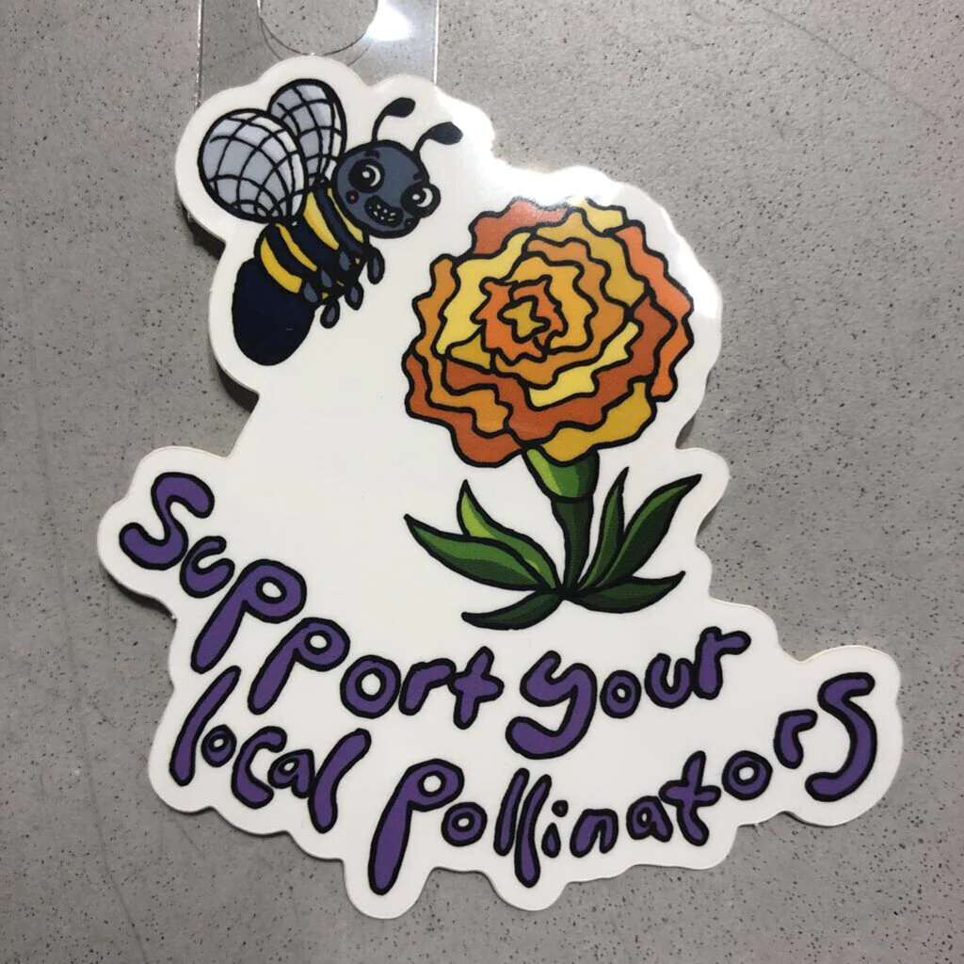

| **Viktor** | **fly** |
| --- | --- |
| **Koni** | **bee** |
| **Merse** | **butterfly** |
| **Levente** | **ant** |
| **Emma** | **Stag beetle** |
| **Lizi** | **Rose Chafer** |
| **Medárd** | **Moth- molylepke** |
| **Hanna** | **long-horned beetle- cincér** |
| **Robi** | **ladybug** |
| **Krisztina** | **grasshopper** |
| **Levi** | **Dung beetle- ganajtúró** |
| **Oli** |  |